ANNUAL REPORT (2024-25)
01 July 2024- 30 June 2025
Department of Computer Science & Engineering
Faculty of Engineering & Technology
Established (year): 2000
About the Department:
The Computer Science & Engineering department, established in 2000, has grown exponentially since its inception. Initially offering 30 seats in B.Tech , it has now 225 seats in B.Tech, and have started M.Tech from 2024, B.Tech (Working Professional) from 2024 and Ph.D from 2019 reflecting the unwavering faith in its quality education. The department is a pioneer in introducing cutting-edge courses like Cloud Computing, Machine Learning, and Blockchain. With a faculty composed of experienced professionals, the department has produced alumni thriving in prominent IT firms and PSUs. MoU with companies like IBM provide students skill oriented courses. Its visionary approach has left an indelible mark on the field, making it a hub of innovation and excellence.
Head of the Department: Dr. Mayank Aggarwal
Faculty Members:
- Dr. Mayank Aggarwal
- Dr. Suyash Bhardwaj
- Dr. Nishant Kumar
- Mr. Namit Khanduja
- Mr. Vivudh Fore
- Dr. Aman Tyagi
- Mr. Ashwani
- Mr. Aman Tyagi
- Mr. Shashank Sharma
- Mr. Mukesh Kumar Arya
- Mr. Kuldeep
- Mr. Abhishant
Adjunct Faculty:
- Dr. Mani Madhukar, IBM
Details of Publication/Conference attended/ Workshop attended/ Awards/ Invited talk etc.:
- No. of publications in UGC listed journals with impact factors (if any): 08 – Annexure 1
- No. of books/edited books/chapters in books: 05 – Annexure 2
- No. of papers presented in conferences/seminars by the faculty members: 15 – Annexure 3
- No. of awards to faculty members: 08 – Annexure 4
- No. of Patents: 02 – Annexure 5
- No. of Projects sanctioned: 01 Annexure 6
- No of Invited talk delivered: 33- Annexure 7
- No. of FDP/ Workshop Attended 17– Annexure 8
- No. of Events Organized: 12 – Annexure 9

Head

Annexure 1
Paper Published in journal
- A.Sharma,M. Aggarwal “A holistic review of Image to text conversion: Techniques, Evaluation Metrics, Multilingual Captioning, Storytelling and Integration”, Springer Nature Computer Science (Scopus), Online ISSN 2662-995X, Vol 6 , Article No 225, 25 Feb, 2025, doi: https://doi.org/10.1007/s42979-025-03719-60
- A.Arora,M. Aggarwal “Blockchain-Based trust and AI driven water quality prediction in river systems”, Springer Nature Computer Science (Scopus), Online ISSN 2662-995X, Vol 5 , Article No 954, 12 Oct, 2024, doi: https://doi.org/10.1007/s42979-024-03315-0
- N.Patel,A.Arora,M. Aggarwal “Evaluating simulation tools for securing sensor data with blockchain:A comprehensive analysis “, Measurement: Sensors (Scopus), Online ISSN 2665-9174, Vol 33 June 2024, doi:https://doi.org/10.1016/j.measen.2024.101233.
- Dr. Suyash Bhardwaj Published a paper on “Building Ethical and Sustainable Artificial Intelligence through Vedic Science and Engineering” in Vaidika Vàg Jyotih. [UGC Care listed] [National] Vol. 12, No. 22 (145-164) January-June 2024, ISSN 2277-4351.
- Deepak Painuli and Dr. Suyash Bhardwaj Published a paper on “Efficient Feature Selection and Hyperparameter Tuning for Improved Speech Signal-Based Parkinson’s Disease Diagnosis via Machine Learning Techniques” in Health Technology Assessment in Action, Scopus Indexed [International] Vol 9, No. 1 October 2024 PP- 26-41. ISSN - 2645-3835.
- Kumar, A., Kumar, N., Kuriakose, J., & Sisodia, P. S. (2024). ”A deep transfer learning based approaches for the detection and classification of acute lymphocytic leukemia using microscopic images”. [SCI, SCOPUS INDEX] Multimedia Tools and Applications, 1-25.
- Khanduja, N., Kumar, N., & Chauhan, A. (2024). ”Telugu language hate speech detection using deep learning transformer models: Corpus generation and evaluation. Systems and Soft Computing”, 6, 200112. Scopus Indexed [International]
- Dr. Aman Tyagi and Mr. Namit Khanduja (2025). Automatic laptop purchase system based on case base reasoning technique. International Journal of Business Forecasting and Marketing Intelligence, 10(2), 165-184. [Peer-Review]

Annexure 2
Book/Book Chapter Published
- Dr. Mayank Aggarwal Authored a Chapter titled “Navigating the ethical cross roads of generative AI in healthcare” in Book titled “Generative AI in Healthcare” by CRC Press( Taylor & Francis) .July,2025. ISBN-9781003408246. Link Gen AI in Healthcare
- Dr. Mayank Aggarwal Authored a Book titled “Cloud & Code: A Comprehensive Guide to Python Web Development and Cloud Integration”, Publisher Shroff Publishers & Distributors Pvt. Ltd., March, 2025. ISBN: 978-93-5542-834-9. PP-136. Link : Cloud & Code.
- Dr. Suyash Bhardwaj authored a book chapter titled “Enhancing Customer Targeting in E-Commerce and Digital Marketing through AI-Driven Personalization Strategies” in book titled “Advances in Digital Marketing in the Era of Artificial Intelligence” by CRC Press, Taylor and Francis group on 12 July 2024, ISBN, 978-10-0345-044-3. https://doi.org/10.1201/9781003450443.
- Dr. Suyash Bhardwaj authored a book chapter titled “Transforming Agriculture with IoT for Precision Agriculture and Sustainable Crop Management” in book titled “The Future of Agriculture: IoT, AI and Blockchain Technology for Sustainable Farming” by Bentham Science Publishers Pte. Ltd. Singapore, on 06 November 2024, PP 164-200, ISBN: 978-981-5274-35-6 (Print) ISBN: 978-981-5274-34-9 (Online) DOI: 10.2174/9789815274349124010012.
- Mr. Kuldeep Giri Authored a Chapter titled “Calorimetric Nanobiosensors: Revolutionizing Precision Agriculture for Sustainable Crop Management” in Book titled “In Nanobiosensors for Crop Monitoring and Precision Agriculture .2025. ISBN-9789819683345(Print) ISBN: 9789819683345(Online). Singapore: Springer Nature Singapore.

Annexure 3
Paper Presented in Conference

- Dr. Suyash Bhardwaj Presented a paper entitled “AI in Financial Fraud Detection: Implications for Mental Health Stability” in International Conference on Yoga, human Consciousness & Artificial Intelligence: in special reference to Global Peace and well-being organized by Department of Yogic Science, Gurukula Kangri Deemed to be University, Haridwar during 21-22 October 2024.
- Dr. Suyash Bhardwaj Presented a paper entitled “The role of AI in detecting plant leaf diseases for physical wellbeing” in International Conference on Yoga, human Consciousness & Artificial Intelligence: in special reference to Global Peace and well-being organized by Department of Yogic Science, Gurukula Kangri Deemed to be University, Haridwar during 21-22 October 2024.
- Dr. Suyash Bhardwaj Presented a paper entitled “INTOCS: Neural Network inspired Oversampling based secure and optimized Transaction Framework for Credit Card” in 2nd international conference on advances in Computation, Communication and Information Technology Technically sponsored by IEEE Delhi Section organized by Department of Computer Science & Engineering, School of Engineering & Technology, Manav Rachna International Institute of Research and Studies, Faridabad, India on 28-29 November, 2024. [Full Length Paper]
- Dr. Suyash Bhardwaj Presented a paper entitled “A Systematic Review for Anomaly Detection in Financial Transactions” in 4th international conference on mathematical modelling and computational science (ICMMCS-2025) organized by Society for Intelligent Systems held at Pattaya, Thailand on 10-11 January, 2025. [Full Length Paper]
- Dr. Suyash Bhardwaj Presented a paper entitled “Early Detection of Tomato Leaf Disease Using Machine Learning” in International Conference on Innovative Computing & Communication in The Field of Life Sciences, Agriculture and Technology” Organized by Department of Computer Science & Department of Agriculture Engineering, CCS University, Meerut on 7-9 February 2025.
- Dr. Suyash Bhardwaj Presented a paper entitled “Machine Learning Applications for Solar Radiation Prediction and Effects of solar radiation in Himalayan Terrain” in International Conference on Innovative Computing & Communication in The Field of Life Sciences, Agriculture and Technology” Organized by Department of Computer Science & Department of Agriculture Engineering, CCS University, Meerut on 7-9 February 2025. [Full Length Paper]
- Dr. Suyash Bhardwaj Presented a paper entitled “Smart Farming Using Artificial Intelligence and Robotics” in 4th International Conference on Global Perspectives on Smart Agriculture: From Precision Farming to Community Empowerment organized by RNB Global University, Bikaner on 27-28 February, 2025. [Full Length Paper]
- Dr. Suyash Bhardwaj Presented a paper entitled “Machine Learning for Stock Market Forecasting: Trends and Techniques” in International Conference on Automation for Sustainable Future (INCASF- 2025) organized by Faculty of Engineering & Technology, Gurukula Kangri (Deemed to be University), Haridwar on 07-08 March, 2025
- Dr. Suyash Bhardwaj presented a paper entitled “Early Detection of Tomato Leaf Disease using Machine Learning Techniques” in International Conference on Automation for Sustainable Future (INCASF- 2025) organized by Faculty of Engineering & Technology, Gurukula Kangri (Deemed to be University), Haridwar on 07-08 March, 2025.
- Dr. Suyash Bhardwaj Presented a paper entitled “Preserving Traditional Knowledge using IPR” in two day national conference on GI Tags: Enhancing Global Recognition of Local sponsored by Uttarakhand State Council of Science and Technology organized by Swami Vivekanand Govt. Post Graduate College, Lohaghat (Distt. Champawat), Uttarakhand on 24-25 March, 2025.
- Dr. Nishant Kumar Presented a paper entitled “DeepFM-Driven Personalized Recommendations for Children: Tackling Data Sparsity with Negative Sampling” in International Conference on Automation for a sustainable Future (INCASF- 2025) organized by Faculty of Engineering & Technology, Gurukula Kangri (Deemed to be University), Haridwar on 07-08 March, 2025
- Dr. Nishant Kumar Presented a paper entitled “Text classification techniques for low resource Indian languages: Challenges and trends” in International Conference on Automation for a sustainable Future (INCASF- 2025) organized by Faculty of Engineering & Technology, Gurukula Kangri (Deemed to be University), Haridwar on 07-08 March, 2025.
- Mr. Namit Khanduja Presented a paper entitled “Text classification techniques for low resource Indian languages: Challenges and trends” in International Conference on Automation for a sustainable Future (INCASF- 2025) organized by Faculty of Engineering & Technology, Gurukula Kangri (Deemed to be University), Haridwar on 07-08 March, 2025.
- Mr. Kuldeep Giri Presented a paper entitled “Machine Learning for Environmental Analysis: Enhancing Forecasting Accuracy and Informed Decision-Making"” in International Conference on Automation for a sustainable Future (INCASF- 2025) organized by Faculty of Engineering & Technology, Gurukula Kangri (Deemed to be University), Haridwar on 07-08 March, 2025.
- Mr. Abhishant Sharma Presented a paper entitled “Automation for sustainable future"” in International Conference on Automation for a sustainable Future (INCASF- 2025) organized by Faculty of Engineering & Technology, Gurukula Kangri (Deemed to be University), Haridwar on 07-08 March, 2025.

Annexure 4
Awards
- Dr.Mayank Aggarwal , awarded IBM Skills build Champion Award by IBM on 16,Oct,2024.
- Dr. Suyash Bhardwaj Awarded with Translator Certificate for Translating the files of the course on Demystifying Networking (106101209) offered by IIT Bombay in Hindi language on July 01,2024.
- Dr. Suyash Bhardwaj Awarded with Active SPOC Award for Jan- June 2024 Session at NPTEL SPOC Felicitation workshop at IIT Kanpur, Kanpur, U.P. on the date on Aug 11, 2024 by National program on technology enhanced learning, NPTEL, Govt. of India.
- Dr. Suyash Bhardwaj Awarded with Special Aspirant Active SPOC Award for July- Dec 2024 Session at NPTEL SPOC Felicitation workshop at Manav Rachna University, Faridabad on March 01, 2025 by National program on technology enhanced learning, NPTEL, Govt. of India.
- Dr. Suyash Bhardwaj Awarded with Top Performing Mentor Award in Programming for Java for July- Dec 2024 Sessions at NPTEL SPOC Felicitation workshop at Manav Rachna University, Faridabad on March 01, 2025 by National program on technology enhanced learning, NPTEL, Govt. of India.
- Dr. Suyash Bhardwaj Awarded with Active Mentor Award in The Joy of Computing using Python for July- Dec 2024 Sessions at NPTEL SPOC Felicitation workshop at Manav Rachna University, Faridabad on March 01, 2025 by National program on technology enhanced learning, NPTEL, Govt. of India.
- Dr. Suyash Bhardwaj Awarded with Active Mentor Award in Problem Solving Through Programming in C for July- Dec 2024 Sessions at NPTEL SPOC Felicitation workshop at Manav Rachna University, Faridabad on March 01, 2025 by National program on technology enhanced learning, NPTEL, Govt. of India.
- Dr. Suyash Bhardwaj Awarded with Special Aspirant Active SPOC Award for July- Dec 2024 Session at NPTEL SPOC Felicitation workshop at Manav Rachna University, Faridabad on March 01, 2025 by National program on technology enhanced learning, NPTEL, Govt. of India.

Annexure 5
Patent Granted
- Dr. Suyash Bhardwaj published and got the patent granted for Patent no. 455110-001 “Self-powered study desk foot platform for sustainable energy” as Indian Patent registered in the Official Journal of the Patent Office, with filed on 12/04/2025 Published on 16/07/2025.
- Dr. Aman Tyagi, published and got the patent granted for Design Number: 424310-001 “AI-BASED OXYGEN CONCENTRATOR” as Indian Patent registered in the Official Journal of the Patent Office Published on 24/07/2024.

Annexure 6
Project Sanctioned
1. UCOST sponsored Research Project on “Study and Development of Effective Machine learning model for Monitoring of Solar Erythemal Ultraviolet Radiation and preparation of UV Map of Uttarakhand Region” sanctioned on UCOST-RND/23/2024-UCOST-DPT26325, Date: 10-09-2024.

Annexure 7
Invited Talk Delivered
- Dr. Mayank Aggarwal acted as resource person, One Week AICTE Sponsored ATAL FDP, at MIT, Meerut. 17/6/25.
- Dr. Mayank Aggarwal acted as Resource Person, One Week UGC Sponsored Refresher Course, at GNDU, Amritsar 3/2/25.
- Dr. Mayank Aggarwal acted as Resource Person, One Week UGC Sponsored STC on Cyber Crime and Cyber Security, at Kurukshetra University, Kurukshetra, 28/11/24.
- Dr. Mayank Aggarwal acted as Resource Person for a two-day workshop on “Exploring Blockchain and Artificial Intelligence Using IBM Watson” at Uttaranchal University, Dehradun, 7-8 October 2024.
- Dr. Mayank Aggarwal acted as Resource Person in a two-day workshop on “Exploring Blockchain and Artificial Intelligence Using IBM Watson” at Shobit University, Gangoh, during a pre-conference workshop of International Workshop, 17-18, Oct, 2024.
- Dr. Mayank Aggarwal acted as Resource Person in a two-day workshop on “Exploring Blockchain and Artificial Intelligence Using IBM Watson” at Uttaranchal University, Dehradun, under the aegis of IEEE 7-8, October 2024.
- Dr. Mayank Aggarwal acted as Keynote Speaker, National Conference on “Recent Innovations in Engineering Science & Technology”, at JBIT Dehradun sponsored by USERC on 21/09/2024.
- Dr. Mayank Aggarwal acted as Resource Person in One Week Online STC sponsored by UGC on “Securing Applications using Blockchain” at GNDU, Amritsar, 14/9/24.
- Dr. Mayank Aggarwal acted as Resource Person/Invited talk on “Exploring Blockchain” at a workshop at Haridwar University on 14/09/24.
- Dr. Mayank Aggarwal acted as Resource Person in a two-day workshop on “Blockchain and Artificial Intelligence” at DBU, Dehradun under the aegis of IEEE 7-8, September 2024.
- Dr. Mayank Aggarwal acted as Coordinator for a session at AI Conclave for Uttarakhand organized by UCOST 5/08/2024.
- Dr. Mayank Aggarwal Conducted hands-on workshop on “Exploring Blockchain and AI Using Ethereum and IBM Watson” at Chitkara University, Chandigarh (15-18, July,2024)
- Dr. Suyash Bhardwaj Delivered an Expert Lecture on “NPTEL Enrollement process and Benefits of MOOC Courses” in NPTEL Awareness workshop organized by SWAYAM NPTEL Committee of Gurukula Kangri Deemed to be University, Haridwar on 15 July 2024.
- Dr. Suyash Bhardwaj Delivered an Invited talk on “Artificial Intelligence and its application” in international conference on Artificial Intelligence organized by Adhyatm yog sansthan, new delhi on 17 September, 2024.
- Dr. Suyash Bhardwaj Delivered an invited talk as Keynote Speaker on “Intellectual Property Rights and Innovation in India” in one day National Seminar on “Intellectual Property Rights” sponsored by UCOST and organized by IPR Cell, Chaman Lal Mahavidhyalaya, Landhaura, Haridwar on 21 September 2024.
- Dr. Suyash Bhardwaj Delivered an invited talk on “Intellectual Property Rights and its application” at ABES Engineering College Ghaziabad on 14 October 2024.
- Dr. Suyash Bhardwaj Delivered an invited talk on “Intellectual Property Rights and its application” at ABES Engineering College Ghaziabad on 23 November 2024.
- Dr. Suyash Bhardwaj Delivered an invited talk on “Design Thinking, Critical Thinking and Innovation Design” at Government Polytechnic, Ranipokhari, Ghmandpur, Ranipokhari, Dehradun on 04 December 2024.
- Dr. Suyash Bhardwaj Delivered an Invited talk on “NPTEL Awareness and Enrolment” in the NPTEL awareness workshop organized by SWAYAM NPTEL Local chapter Gurukula Kangri University, haridwar on 18 Jan 2025.
- Dr. Suyash Bhardwaj Delivered an Invited talk on “Innovation and Design Thinking” in Digital Volunteers Workshop organized by Faculty of Engineering & Technology, Gurukula Kangri Deemed to be University, Haridwar supported by Uttarakhand State Council for Science & Technology, Dehradun on 24 Jan, 2025.
- Dr. Suyash Bhardwaj Delivered an invited talk on “Artificial Intelligence and Modern Technologies” in Digital Volunteers Workshop organized by Faculty of Engineering & Technology, Gurukula Kangri Deemed to be University, Haridwar supported by Uttarakhand State Council for Science & Technology, Dehradun at Rajkiya Polytechnic Siggadi, Kotdwar, Uttarakhand on on 31 Jan, 2025.
- Dr. Suyash Bhardwaj Delivered an Invited talk on “Application of AI and ML in Pharmaceutical Sciences” organized by Department of Pharmaceutical science, Gurukula Kangri Deemed to be University, Haridwar on 04 Feb 2025.
- Dr. Suyash Bhardwaj Delivered an Invited talk on “AI in Research and R Programming” in National Workshop on Advance Computational & Statistical Techniques for Research organized by Department of Pharmaceutical Science, Gurukula Kangri Deemed to be University, Haridwar on 06 March 2025.
- Dr. Suyash Bhardwaj Acted as session chair and delivered the lecture on “Scientific Temperament in students” in the “Uttrakhand Tech Summit” organized by Reacha Foundation in collaboration with IBM at ITI Niranjanpur, Dehradun on 18 March 2025.
- Dr. Suyash Bhardwaj Acted as resource person and delivered an invited talk on “Digital Volunteer for Uttarakhand and introduction to Artificial Intelligence” in Digital Volunteers Workshop organized by Faculty of Engineering & Technology, Gurukula Kangri Deemed to be University, Haridwar supported by Uttarakhand State Council for Science & Technology, Dehradun at Swami Vivekananda Government PG College, Lohaghat, Champawat, Uttarakhand on 24 March, 2025.
- Dr. Suyash Bhardwaj Acted as resource person and delivered an invited talk on “Digital Volunteer for Uttarakhand and Latest Technologies” in Digital Volunteers Workshop organized by Faculty of Engineering & Technology, Gurukula Kangri Deemed to be University, Haridwar supported by Uttarakhand State Council for Science & Technology, Dehradun at Government Girls Inter College, Lohaghat, Champawat, Uttarakhand on 25 March, 2025.
- Dr. Suyash Bhardwaj Delivered an invited talk on “Intellectual Property Rights” at APEX university, Jaipur on 08 April, 2025.
- Dr. Suyash Bhardwaj Delivered an invited talk on “Cyber Security for Students” at DAV, Jagjeetpur, Haridwar on 22 April, 2025.
- Dr. Suyash Bhardwaj Delivered an invited talk on “latest Tools for Software Development” at NIET, Noida on 25 April 25.
- Dr. Suyash Bhardwaj Delivered an invited talk on “Web Technologies” at Dev Sanskriti Vishwavidyalaya, Haridwar on 27 April 25.
- Dr. Suyash Bhardwaj Delivered an invited talk on “Research Methodology and Research Ethics" at Lal Bahadur Shastri Rashtriya Sanskrit Vishwavidyalaya on 16 May 2025.
- Dr. Suyash Bhardwaj Delivered an invited talk on "Application of Computer Science and Research Writing" at Lal Bahadur Shastri Rashtriya Sanskrit Vishwavidyalaya on 17 May 2025.
- Dr. Nishant Kumar Acted as resource person and delivered an invited talk on “Digital Volunteer for Uttarakhand and Latest Technologies” in Digital Volunteers Workshop organized by Faculty of Engineering & Technology, Gurukula Kangri Deemed to be University, Haridwar supported by Uttarakhand State Council for Science & Technology, Dehradun on 31/01/2025.
Annexure 8
FDP/Workshop Attended
- Dr. Mayank Aggarwal attended Faculty Development Program on “AI for future worksforoce” organized by “NITTTR-Chandigarh” from 22/07/24 to 26/07/2024.
- Dr. Mayank Aggarwal attended Faculty Development Program on “Quantum Technologies and Applications” organized by “MNIT Jaipur” from 28 Feb- 22 March,2025.
- Dr. Mayank Aggarwal attended Faculty Development Program on “Foundations of Quantum Technologies” organized by “MNIT Jaipur” from 11 April – 3 May,2025.
- Dr. Mayank Aggarwal attended Faculty Development Program on “Basics of Quantum Programming” organized by “MNIT Jaipur” from 16 May – 7 June,2025.
- Dr. Suyash Bhardwaj attended UGC Sponsored Refresher Course in Research Writing and Academic Integrity at MMTTC, Kumaun University, Nainital during February 18, 2025 to March 04, 2025.
- Dr. Suyash Bhardwaj attended Faculty Development Program on “NEP 2020 Orientation and Sensitization Program” organized by the MMTT Centre, HNB Garhwal University, Srinagar (Garhwal), Uttarakhand from 22 July 2024 to 31 July, 2024. [10 Days]
- Dr. Suyash Bhardwaj attended AICTE ATAL Faculty Development Program on “Generative AI and It’s Applications with Computer Vision” organized by Lalbhai Dalpatbhai College of Engineering. Ahmedabad from 16 Dec 2024 to 21 Dec 2024. [One week].
- Dr. Suyash Bhardwaj attended Faculty Development Program on “Multi-Disciplinary Education & Research with Emphasis on Indian Knowledge System” from 21st-27th January 2025 organized by the Faculty of Science, Motherhood University, Roorkee, Uttarakhand. [One Week]
- Dr. Suyash Bhardwaj attended National workshop on Advance Computational & Statistical Techniques for Research organized by Department of Pharmaceutical sciences, Gurukula Kangri Deemed to be University, Haridwar on 06th march 2025.
- Mr. Mukesh Chandra Arya attended Faculty Development Program on “Blockchain-Powered Machine Learning: Future of AI Security and Transparency” organized by “O.P. Jindal University, Raigarh” from 19/05/25 to 23/05/2025.
- Mr. Mukesh Chandra Arya attended Faculty Development Program on “Exploring AI using IBM waston and google colab” organized by “G.K.V., Haridwar” from 03/02/25 to 08/02/2025.
- Dr. Aman Tyagi attended Faculty Development Program on “Exploring AI using IBM waston and google colab” organized by “G.K.V., Haridwar” from 03/02/25 to 08/02/2025.
- Dr. Nishant Kumar attended Faculty Development Program on “Exploring AI using IBM waston and google colab” organized by “G.K.V., Haridwar” from 03/02/25 to 08/02/2025.
- Mr. Namit Khanduja attended Faculty Development Program on “Exploring AI using IBM waston and google colab” organized by “G.K.V., Haridwar” from 03/02/25 to 08/02/2025.
- Mr. Aswani attended Faculty Development Program on “Exploring AI using IBM waston and google colab” organized by “G.K.V., Haridwar” from 03/02/25 to 08/02/2025.
- Mr. Kuldeep Giri attended Faculty Development Program on “Exploring AI using IBM waston and google colab” organized by “G.K.V., Haridwar” from 03/02/25 to 08/02/2025.
- Mr. Abhishant Sharma attended Faculty Development Program on “Exploring AI using IBM waston and google colab” organized by “G.K.V., Haridwar” from 03/02/25 to 08/02/2025.

Annexure 9
Events Organized:
Report on the Two-Day Workshop on Artificial Intelligence and Cyber Security 27-28 August 2024
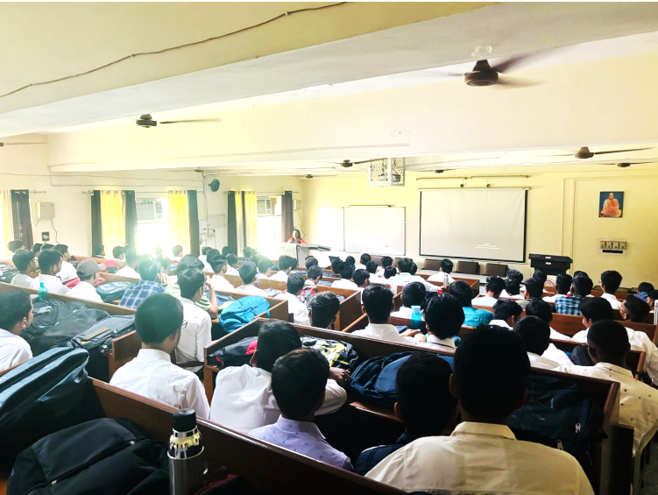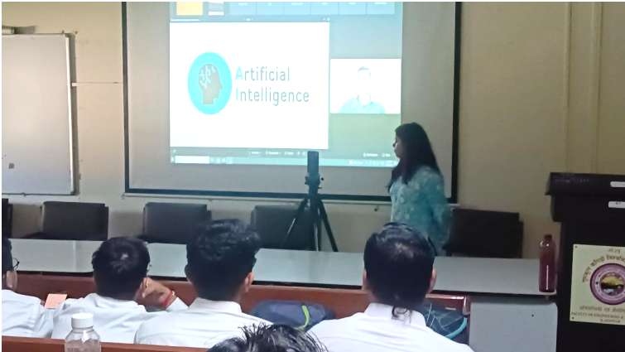

Hindi Week celebrations in FET 12 September 2024
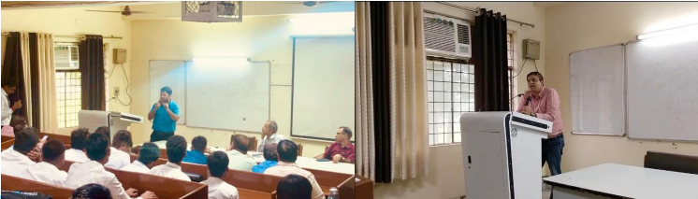
Engineers' Day Celebration at the Department of Computer Science and Engineering 14 September 2024
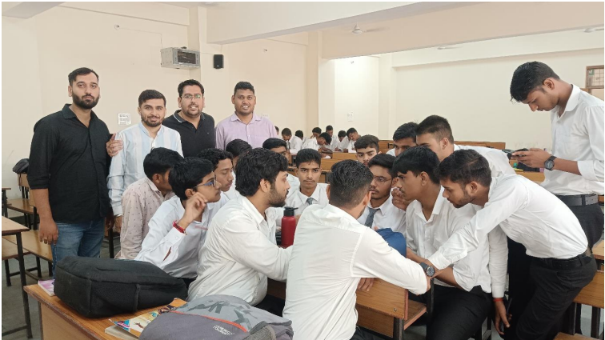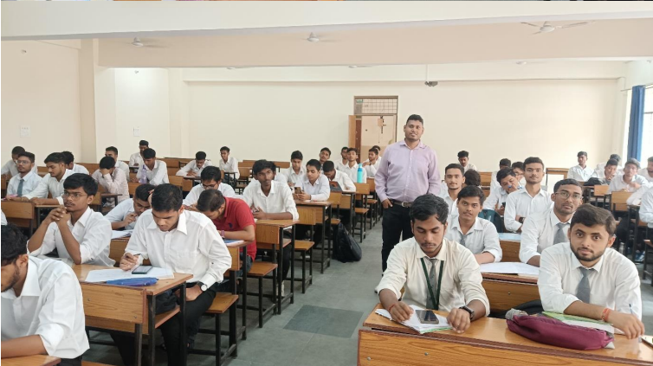
Freshmen Induction Program September 21, 2024
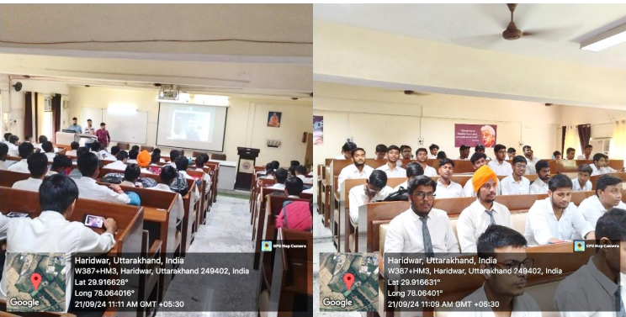
Plantation Drive Held at Faculty of Engineering and Technology, Gurukul Kangri Deemed to be University, Haridwar on World Environment Day 05 June 2025
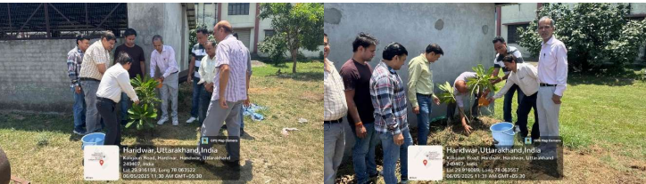
Report on NPTEL Awareness and Enrollment Session 18 January 2025
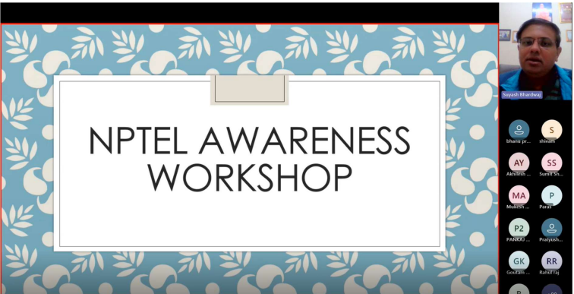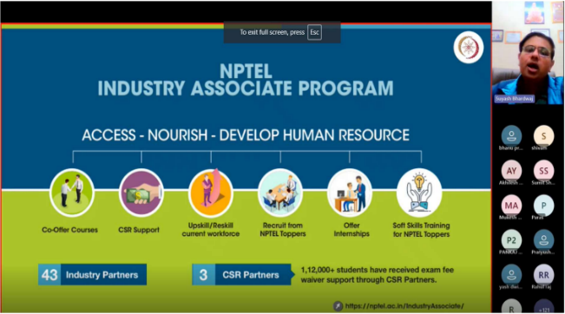

Digital Volunteer for Uttarakhand Workshop Successfully Organized at Gurukul Kangri (Deemed to be University), Haridwar 24-25 January 2025
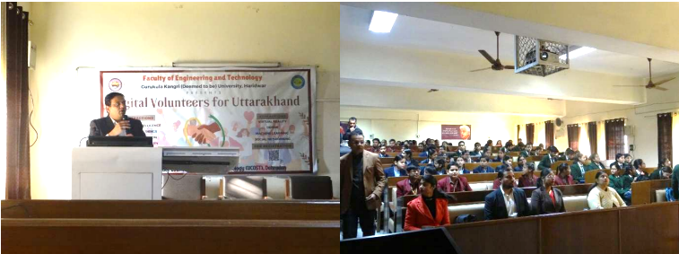
Digital Volunteer Workshop at Government Girls College, Kotdwar on 29 January, 2025
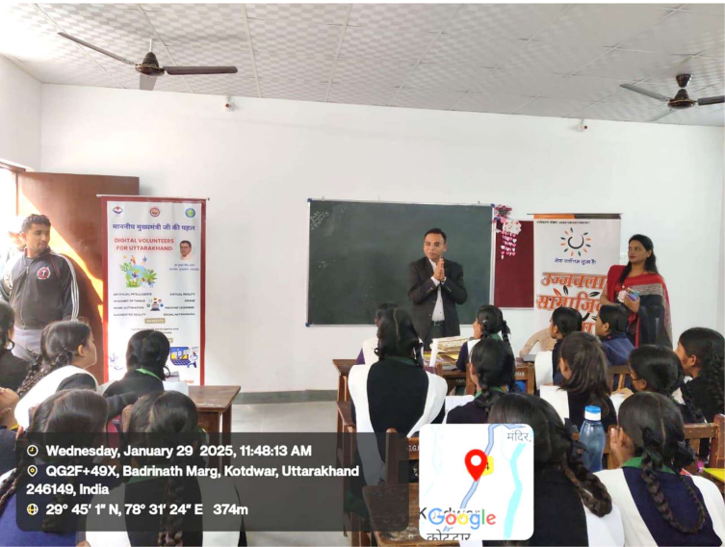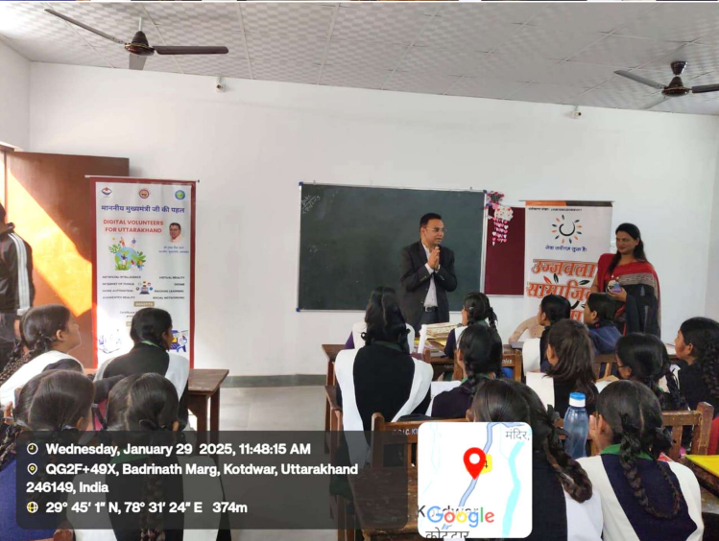
Digital Volunteer Workshop organised by Uttarakhand State Council of Science & Technology at Government Inter College, Jaidevpur Siggadi, Kotdwar on 31 january, 2025
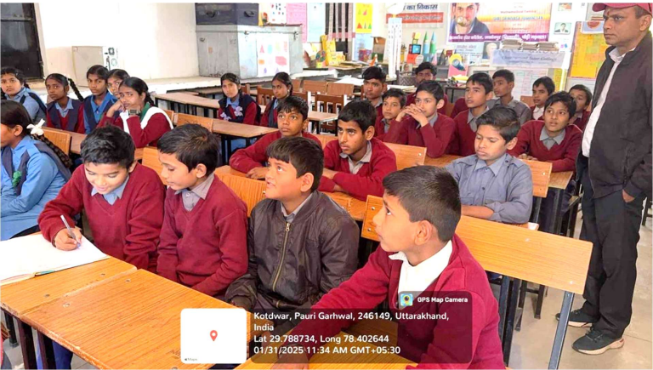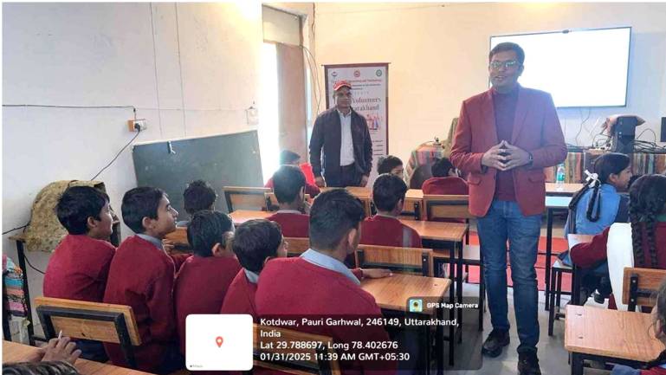
AICTE ATAL Sponsored 5 days Faculty Development Program on Exploring AI Using IBM Watson And Google Colab 03-08, Feb 2025
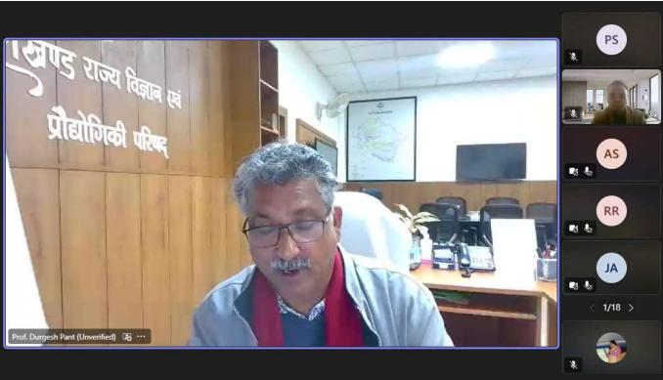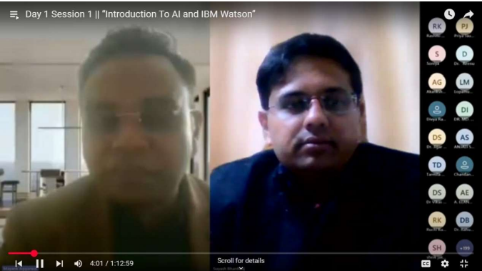
Digital Volunteer for Uttarakhand Workshop 05 March 2025
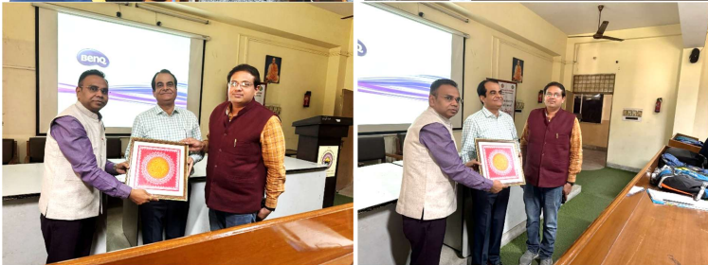
Special Lecture on Innovation and Employability under Digital Volunteer Programme 20 March 2025
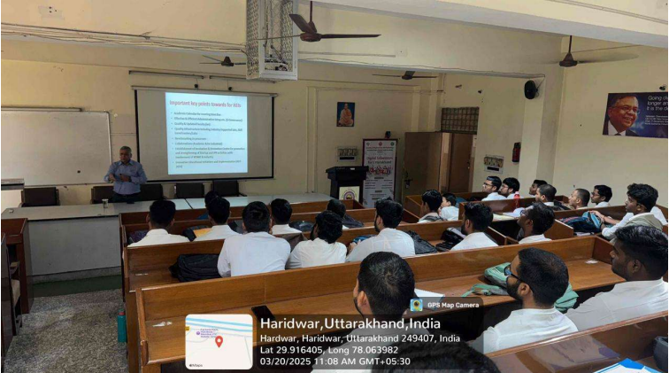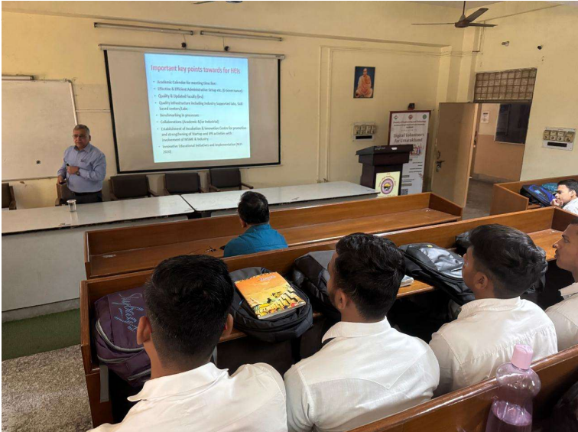

Annexure 9:
Recent Placements and Academic Progression

S. No. | Student's Full Name | Company | Branch | Package in LPA
1 | Anurag Sharma | Bharuwa Solutions | B.Tech CSE | 3,00,000
2 | Piyush Jaiswal | Portway Solutions India Pvt Ltd. | B.Tech CSE | 6,00,000
3 | Ashish Singh | Kloudrac Softwares Pvt Ltd. | B.Tech CSE | 4,50,000
4 | Rudra Prakash Pandey | Knack Tech Pvt. Ltd | B.Tech CSE | 6,00,000
5 | Rahul | Knack Tech Pvt. Ltd | B.Tech CSE | 6,00,000
6 | Raju Kumar Gupta | Knack Tech Pvt. Ltd | B.Tech CSE | 6,00,000
7 | Hariom Singh | Knack Tech Pvt. Ltd | B.Tech CSE | 6,00,000
8 | Alok kumar | Knack Tech Pvt. Ltd | B.Tech CSE | 6,00,000
9 | Souhard Singh | Big OH nation pvt Ltd. | B.Tech CSE | 5,20,000
10 | Alok Kumar | Stellaraa Edutech Private Limited | B.Tech CSE | 12,00,000
11 | Alok ranjan jha | Stellaraa Edutech Private Limited | B.Tech CSE | 12,00,000
12 | Ariyan Kumar  Mahakur | Stellaraa Edutech Private Limited | B.Tech CSE | 12,00,000
13 | Bikram Ghoshal | Stellaraa Edutech Private Limited | B.Tech CSE | 12,00,000
14 | Harsh Modi | Stellaraa Edutech Private Limited | B.Tech CSE | 12,00,000
15 | Piyush Rathwe | Stellaraa Edutech Private Limited | B.Tech CSE | 12,00,000
16 | Prince Kumar Bhagat | Stellaraa Edutech Private Limited | B.Tech CSE | 12,00,000
17 | Rishabh mishra | Stellaraa Edutech Private Limited | B.Tech CSE | 12,00,000
18 | Ritu Raj | Stellaraa Edutech Private Limited | B.Tech CSE | 12,00,000
19 | Shivansh Pathak | Stellaraa Edutech Private Limited | B.Tech CSE | 12,00,000
20 | Niranjan Kumar | Bharuwa Solutions | B.Tech CSE | 3,00,000
21 | Himanshu Saini | TCS | (2024 Batch) B.Tech CSE | 7,05,000/-
22 | Katuri Karthik | NxtWave Disruptive Technologies Private Limited | B.Tech CSE | 5,60,000/-
23 | Shivansh Pathak | Pentagon Space | B.Tech CSE | Online Incubation  drive
24 | Vishal | Pentagon Space | B.Tech CSE | Online Incubation  drive
25 | Alok Rajan Jha | Tech Mahindra Pool Campus@ Amrapoali  University | B Tech- CSE | 3,50,000
26 | Aran Choudhry | Tech Mahindra Pool Campus@ Amrapoali  University | B Tech- CSE | 3,50,000
27 | Bikram | Tech Mahindra Pool Campus@ Amrapoali  University | B Tech- CSE | 3,50,000
28 | Saurabh Singh | Intellipaat Softwares | B Tech- CSE | 9,00,000

GATE/CAT Qualified students (2024-25)

S.No. | Student Name | Batch | Gate Score
 | Shivansh Chauhan | 2024-25 | 385
 | Manish Kumar | 2024-25 | 357
 | Narina Balaji Venkata Bheemeswara Rao | 2024-25 | 377
 | Akash Kumar | 2024-25 | 506
 | Anshuman Rath | 2024-25 | 491
 | Siddharth | 2024-25 | 452
 | Harsh Modi | 2024-25 | 387

CAT
S.N | Name | Batch | Percentile
1. | Shashwat Gupta | 2024-25 | 97.13

Higher Studies
S.No. | Student Name | Degree Applied for | Institute Name
1. | Rohan Kumar | PGDM | IMI Kolkata,
2. | Chandrachur Singh | M.Tech | Utrecht University

